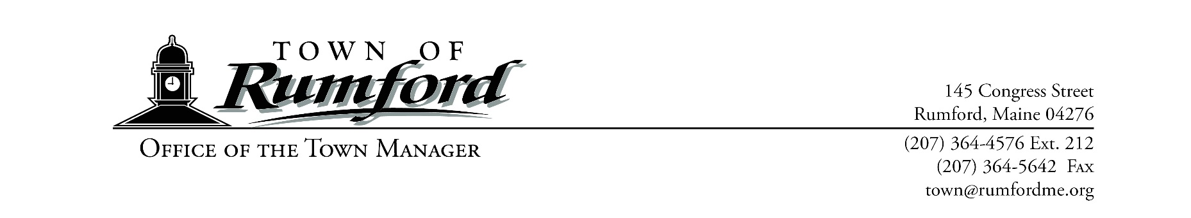

January 04, 2024

Dear Non-Profit Organization:
The Town Manager’s Office has begun budget preparations for the 2024-2025 Fiscal Year. Please send your annual funding request to the Town Manager’s Office, 145 Congress Street, Rumford, ME 04276 by February 8th, 2024. Enclosed you will find a questionnaire that must be completed and submitted with the information requested at the bottom of the page.
The following schedule lists the meeting dates with the Finance Committee. The Finance Committee is now comprised of all five elected Select Board members and five elected Finance Committee members. Each organization will only need to present their request once to the combined committee.

Required Attendance: March 6, 2024 or March 16, 2024 Requests to Finance Committee

Suggested Attendance: April 18, 2024 Public Hearing for Budget and Warrant Articles, 5:30 p.m.
June 3, 2024 Annual Town Business Meeting, 7:00 p.m. at Mtn. Valley HS
Please note that requests will be heard in the order that your questionnaire and required information is received at the Town Manager’s Office. If you have further questions, please do not hesitate to call 364-4576 x212.
Sincerely,

Stacy Carter
Town Manager
SC/MG
Enclosures: Funding Request Questionnaire for Non-Profit Organizations
W-9 Request for Taxpayer Identification Number and Certification

TOWN OF RUMFORD
FUNDING REQUEST QUESTIONNAIRE FOR NON-PROFIT ORGANIZATIONS
FY 2024-2025

Please complete the following questionnaire when making your request for funding to the Town of Rumford. Please type (or print legibly) all information requested.

NON-PROFIT INFORMATION
Name of Non-Profit:
Mailing Address:
Telephone Number: | Director/Contact:
Date Non-Profit was established:
Amount of Funding Requested:
Explain your need to apply to the Town of Rumford for assistance:

Mission, Purpose or Function Statement:

Number of staff:
Number of volunteers:
Number of residents served in the Town of Rumford:
Total number of all persons served:
Percentage ratio of all persons served to Rumford residents:
Do you maintain an office in Rumford?
Number of Rumford residents employed:
BUDGET INFORMATON
Total budget for 2023-2024:
Current total budget compared to previous year total budget (+/- %):
Percentage ratio of administrative costs to total budget:
Percentage of appropriated funds spent for Rumford residents last year:
What amount of Federal Funding (including grants) do you receive?
What amount of State Funding do you receive?

List the percentage of all funding sources:
Source of Funding Percentage of Funding

CLIENT INFORMATION
What eligibility criteria must be met for clients to receive assistance?

____________________________________________________ ___________________________
Name of person providing this information Title

___________________________________________________
Telephone contact information for above person
Please indicate which meeting of the Finance Committee that you plan to attend:
March 6 ☐ March 13 ☐

A COPY OF THE FOLLOWING MUST BE SUBMITTED WITH YOUR REQUEST
____ Most Recent FY Ending Balance Sheet and Income Statement
____ Completed W-9 Request for Taxpayer Identification Number and Certification (Enclosed)

