Please help us to
BEAUTIFY RUMFORD
& Spread Holiday Cheer!

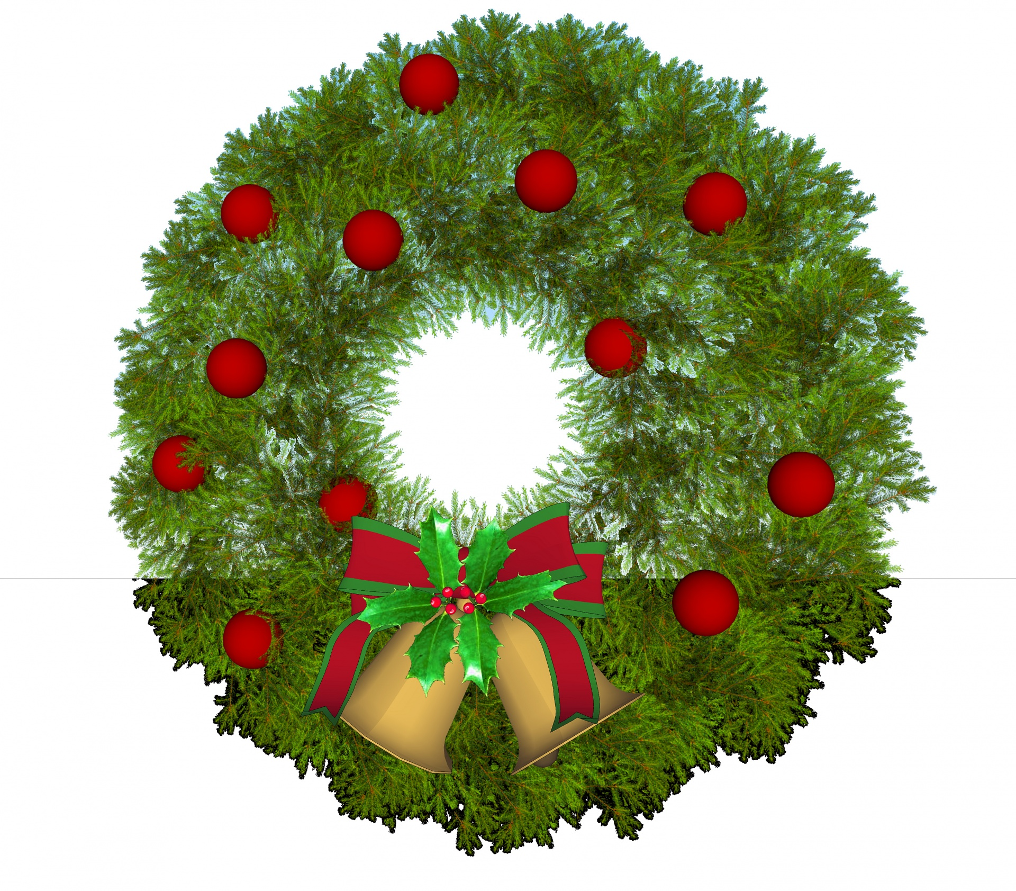
Once again, we will be decorating Rumford for the holidays, and we need YOUR help. Any business, individual or family can sponsor a wreath or a kissing ball and help us to spread EVEN MORE holiday cheer around town for everyone to enjoy!!

Business / Family Name: ______________________________________________
# of Wreaths sponsored: ________________________________________________

Payment: ________________________________________________________________

Price: $25.00 per wreath or kissing ball – each balsam wreath/ball will include a bow
Please make checks payable to Envision Rumford
(all proceeds will be used by Envision Rumford/Beautify Rumford to purchase decorations for our town)

Please drop off your sponsorship form and payment during business hours at the Rumford Town Hall – Town Manager’s office
Or email us at beautifyrumford@gmail.com

