Rumford Revaluation
Assessors / Vehicles
Assessor |  | Vehicle
Rob Duplisea | 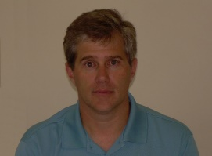 | Grey Mini Cooper
Matt Caldwell |  | White Mitsubishi
Ellery Bane |  | Black Nissan
Kevin McCormick | 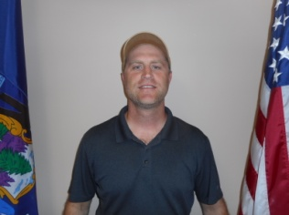 | Blue Mitsubishi
Roger Peppard | 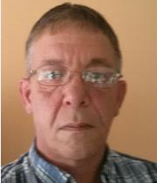 | Silver F150
Zeb Pike | 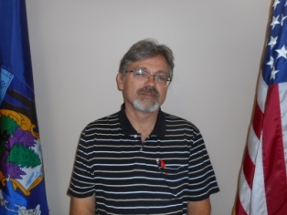 | White Subaru
Jeremy Frye | 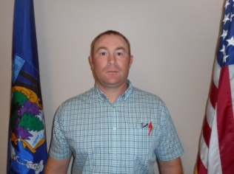 | Silver Hyundai
Ed Hodgins | 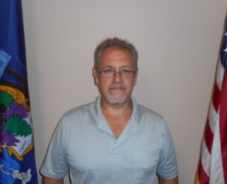 | Gray Subaru
Colby Higgins |  | Maroon Civic
Anthony Maffei |  | Silver RAV 4

